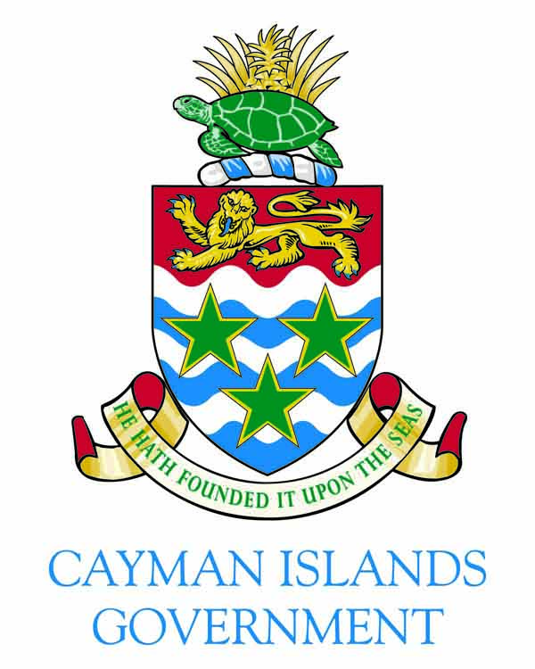

FOR IMMEDIATE RELEASE
15 September 2018
Contact: julie.hutton@gov.ky; angela.piercy@gov.ky

Statement by the Cayman Islands Government on Support for the UK’s National Crime Agency

GRAND CAYMAN, Cayman Islands - In reference to articles reporting the United Kingdom’s National Crime Agency’s (NCA’s) comment that it “struggles” to get data from the Cayman Islands, there is absolutely no merit to Mr. Toon’s allegation. His complaint is a gross misrepresentation of a single situation and is no basis on which to accuse the Cayman Islands of being uncooperative.

Furthermore, the NCA’s recent criticism of Cayman is surprising, bearing in mind that the NCA itself has written to thank the Cayman Islands for its “continuing and excellent support” in relation to an international, high-profile investigation into money laundering.

Since then, there has been only one case in May 2018 in which a legal issue affected Cayman’s response time to a NCA request. That issue was resolved and the information was, in accordance with our commitment to cooperation, provided to the NCA.

Assuming the reporting is accurate, then what is even more worrying is that this baseless attack on Cayman’s economy and reputation appears to be due to our public criticism of and affirmation to challenge the recent attempt by the UK Parliament to legislate for Cayman (and other British Overseas Territories) in areas that are a part of our devolved administration.

The fact that the UK Parliament in May 2018 imposed an unjustifiable and inequitable requirement on the British Overseas Territories and not the Crown Dependancies is bad enough. Now it appears that in furtherance of that agenda the NCA has entered the political arena against what it has previously described as one of its most cooperative and excellent supporters. We hope we are wrong about this and look forward to the NCA correcting the public record.

The Cayman Islands will continue to cooperate and support the NCA and all other law enforcement agencies and tax authorities to combat money laundering, tax evasion and all other forms of crime.
###

