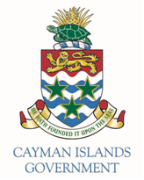

FOR IMMEDIATE RELEASE
Date: 20 September 2018
Issued by: Governor’s Office
Contact: Matthew Forbes, 244-2425, e-mail: Matthew.Forbes@fco.gov.uk

Following an investigation into a number of allegations Mr Choudhury will not return to the Cayman Islands as Governor, but will return to another diplomatic posting in London.

A short term successor will be appointed soon while the recruitment process for a permanent replacement is underway.

##ends##

Notes for Editors:

- The FCO will not be commenting further.

