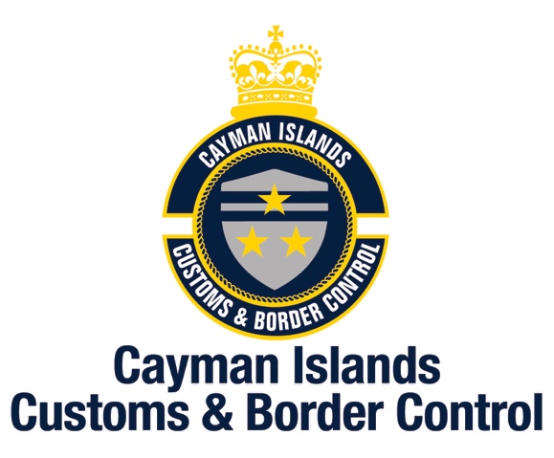

Delivery Address: Mailing Address:
P.O. Box 898
Grand Cayman KY1-1103
CAYMAN ISLANDS

CBC Headquarters
42 Owen Roberts Drive
Grand Cayman
CAYMAN ISLANDS
Telephone (345) 949-4579 / Facsimile (345) 945-1573

Thursday, 6 June 2019
MEDIA RELEASE

CBC Response to OAG Report

“The Customs and Border Control Service, like its predecessor Customs Department, certainly places a great deal of value on audits and audit findings because they provide a platform and opportunity to improve our operations and effectiveness.
We therefore pledge our unequivocal commitment to implement the recommendations that are feasible and funded.
We believe, however, that it would be unfair to the department and the Customs Senior Management Team that was in place at the time of this audit to consider these audit findings in the absence of context. At the time of this audit, the then Customs Senior Management Team had been in place for just over one year.
In the three and a half years preceding August 2015 when the new Collector of Customs took up his appointment, the Customs Department had operated without a permanent Collector. During those three and a half years preceding 2015, the department had been led by 4 different Acting Collectors.
It was therefore understandable that when the new Collector of Customs took up his post in August 2015, he found a department that had been subjected to a number of conflicting and incompatible policies. Consequently, it was not surprising that there were many priorities that demanded his immediate action.
These had to be prioritised based on the following three primary objectives set by the new Collector when he took up the post:
- Increase revenue by closing revenue gaps;
- Improve relationships with other law enforcement agencies in the interest of national security; and
- Succession Planning.
This audit confirms that we have consistently exceeded our revenue targets. In the past three financial years we have exceeded our revenue targets by $10.4 Mil in the 2015/16 fiscal year, $15 Mil in the 2017 fiscal year and $22 Mil in the 2018 fiscal year.
This audit confirms our very positive operational results, including the positive results from many joint operations with the RCIPS and Department of Immigration.
In 2016 the various sections of the department were rationalised under three portfolios:
- Administration;
- Revenue Collection; and
- Border Protection.
There was a Deputy Collector in charge of each portfolio.
In 2016 two Deputy Collectors retired after many years of service and two Assistant Collectors were promoted to the rank of Deputy Collector in 2017 to succeed the retired Deputies.
It follows that the Customs Department’s new Senior Management Team was only in place just over a year ahead of this audit. The newly constituted Senior Management Team enabled the commencement of the transformation of Border Control in the Cayman Islands and this has been significantly enhanced by the merger of the Customs and Immigration Departments on the 1st February 2019.
Specific Management Responses will appear, where appropriate, in the below sections of this audit.
In concluding this general response, we thank the Office of the Auditor General for their professionalism and partnership during this audit. The audit took place at a particularly challenging time for us as we were in the middle of a number of new initiatives at the time, including the roll out of a new IT Platform and intense preparations for the merger mentioned above.
As CBC continues its transformation from the traditional gate keepers approach to an intelligence-led risk management organization, it will continually refine its business processes, intelligence and risk-based strategies using a variety of techniques, technology, training and development in order to provide the best means of identifying and addressing threats at the earliest possible point.”

-END-

