Green Iguana Culling:
Information & Guidelines
The guidance provided below is intended as information for the general public on Grand Cayman. The details below are provided as supplementary information only and do not replace the terms of contracts or terms of participation for registered green iguana cullers.
- Green Iguanas and Rock Iguanas
There are three species of iguana established in the Cayman Islands. Green Iguanas are a harmful invasive species and they are not protected by law. Native Iguanas, such as the Grand Cayman Blue Iguana and the Sister Isles Rock Iguana, are endangered species and are strictly protected under the National Conservation Law.
If Native Iguanas are culled during the Green Iguana cull process, the cullers will be at risk of prosecution under the tenets of the National Conservation Law. Please see “Cayman Islands: Green Iguanas vs. Blue Iguanas” on YouTube or visit the Blue Iguana Recovery Programme website for more information on the differences. The internet links are provided below for ease of reference:

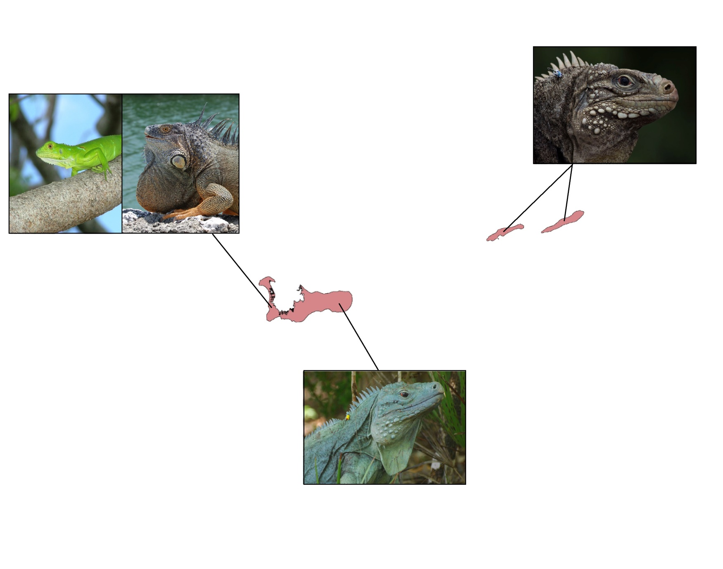
Green Iguana
- Widely distributed on Grand Cayman.
- Present but very scarce in Sister Isles.
- Large scale on cheek.
- Yellow eyes.
- Juveniles bright green.
- Adults can vary in colour and have orange and black banded tails.
Iguanas in the Cayman Islands
Sister Islands Rock Iguana
- Listed as endangered and protected by law.
- Found only in Little Cayman and Cayman Brac.
- Generally brown in colour but sometimes appear grey.
- Juveniles similar in appearance to adults.
- Red eyes.
Blue Iguana
- Listed as endangered and protected by law.
- Found only in the eastern districts of Grand Cayman.
- Generally blue in colour but sometimes appear grey.
- Juveniles similar in appearance to adults.
- Red eyes.
PROTECTED
INVASIVE
PROTECTED
Juvenile
Adult

- Handling of Iguanas
Green iguanas can inflict severe bites, tear a person’s skin with their claws, or whip someone with their long tails. The bigger the iguana, the more damage they can do. All green iguana cullers are responsible for their own safety and should be aware of the ability of these animals to cause injury.
If cullers do get bitten or scratched, they are advised to clean and disinfect the wound promptly to avoid infection.
To minimise the risk of injury when working by hand, noose or snare, it is advised to cull the green iguana quickly after capture. The culler must hold the green iguana while still alive, grasp it behind the head and in front of the back legs, using their hands to restrain the legs, and turn it upside down to subdue it.
- Humane Culling of Green Iguanas
While the Department of Environment is about to commence a large-scale green iguana culling project, it remains a legal requirement that the green iguanas are culled humanely.
Further information of approved techniques for effective, humane capture and culling will be provided to all cullers at registration and will be available upon request for others.
The Department of Environment reserves the right to revoke the registration of any culler upon receiving evidence of a culler treating iguanas in a significantly inhumane manner. A revoked culler will no longer be able to receive payment for any carcasses delivered.
- Delivering Carcases to the Depository at George Town Landfill
Green iguana carcasses will be accepted for counting between 8am and 6pm at the George Town landfill. Cullers must have their registration card and carcasses accessible for counting. The weighing and counting station is to the right of the main landfill entrance office. The number of carcasses and weight of each batch, the culler registration number and name of the registered culler, locations of activities and estimates for how many person-hours of culling it took to cull each batch will be recorded by a member of the cull manager’s staff.
No iguanas will be accepted from cullers who are not registered, or at times outside the designated counting hours.
Payments to the registered cullers will be made by the cull manager.
- Culling Quota and Incentive Scheme
Each registered culler will be working towards a monthly and annual culling quota which is set at registration and updated as necessary. The purpose of the quota scheme is to ensure the overall project meets its target and stays within its budget. An incentive is linked to reaching the quotas, with monthly and annual bonuses making up a small, but significant, part of the maximum of $5 per culled green iguana. Bonuses are paid if the quota targets are met.
- Retaining Iguanas for Consumption
Green iguana meat is edible if prepared safely and can be cooked up in many ways. If a member of the public plans on eating any culled green iguanas, they are advised to disembowel, clean and refrigerate them promptly. Food safety practice for green iguanas is the same as for any wild game.
If the culled green iguana’s body is used for meat, the heads will be accepted for counting at the landfill but must be clearly identifiable as a single green iguana, for example, the entire head must be presented, not merely a section or part of it.
- Public Sensitivities
Some members of the general public may be distressed at the sight of green iguanas being culled. The steps necessary to control the exploding green iguana population may be unpleasant and cullers should always respect possible sensitivities of onlookers.
Always obtain permission from landowners and property managers before entering onto property AND before beginning each culling activity, and respect any conditions they may place on your activity (e.g. no culling when children are in sight). It is up to the individual culler to obtain such permissions from the property owners or managers. A culling contract or registration does not confer any authority to enter any property without the owner or property manager’s permission.

Hyperlink to “Cayman Islands: Green Iguanas vs. Blue Iguanas”: https://www.youtube.com/watch?v=fVTsvkHczio
Hyperlink to Blue Iguana Recovery Programme website: http://www.blueiguana.ky/iguanas/blues-greens/

