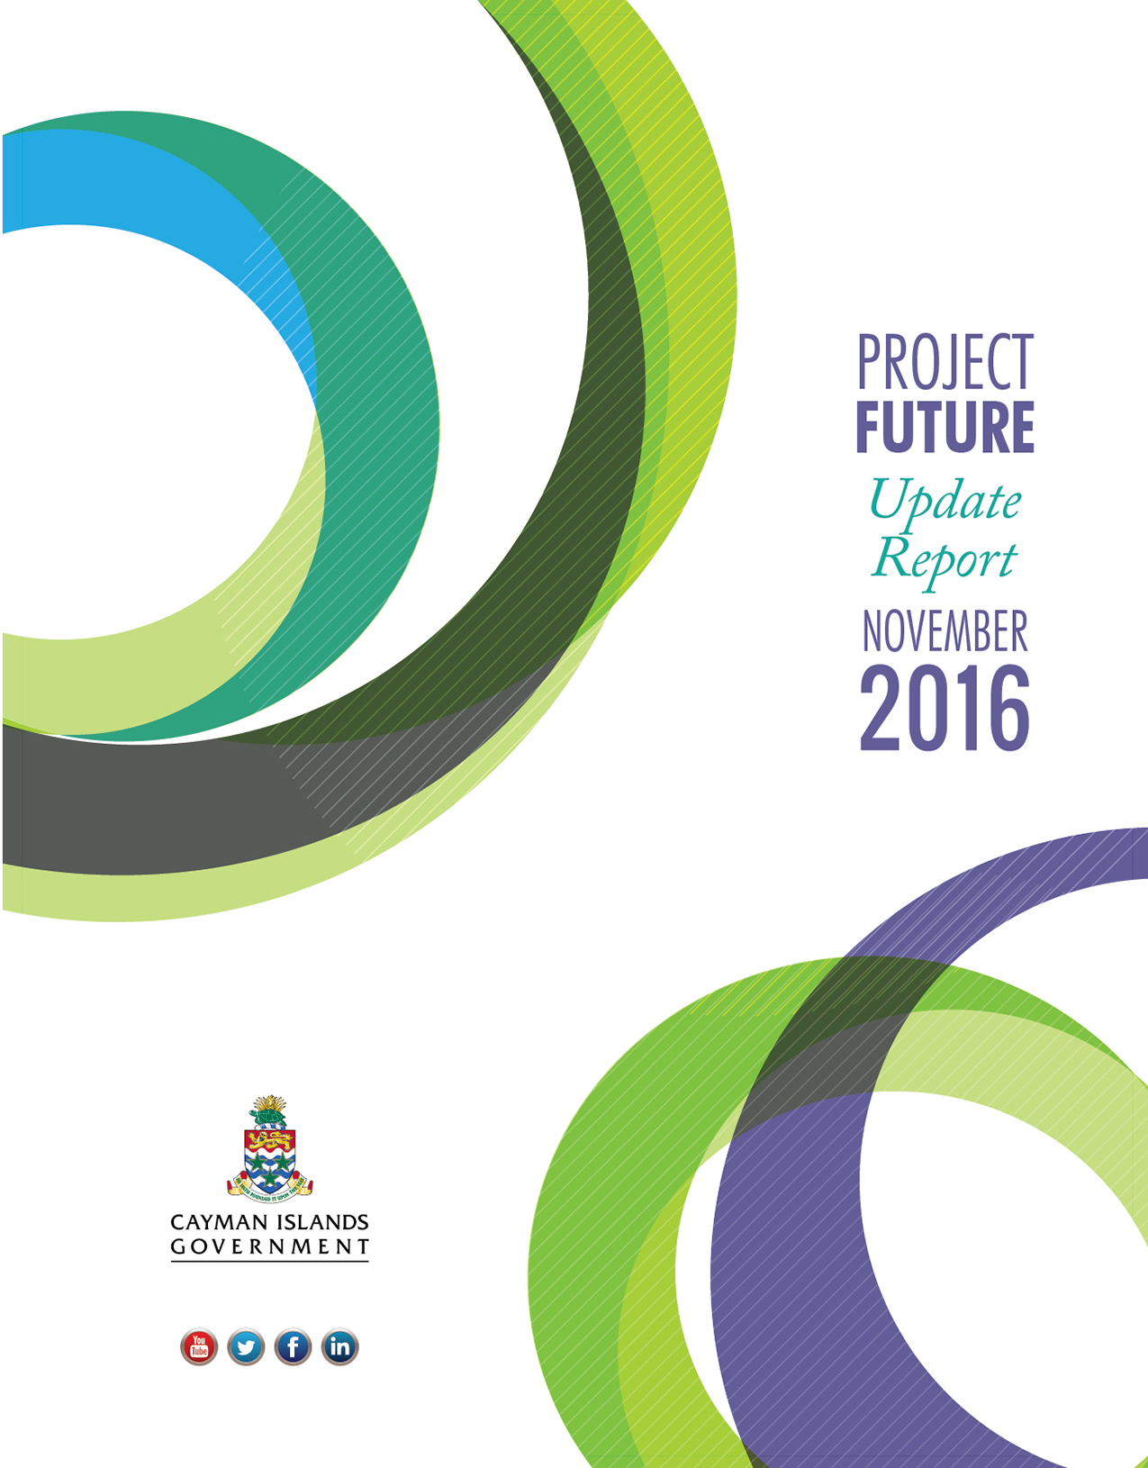

Executive Summary
This executive summary highlights the key messages from the four (4) main sections of this Project Future November 2016 Update Report.

1. INTRODUCTION
This Update Report marks the end of the first year of implementation for the Project Future programme. It provides information on the progress achieved by Project Future projects since the first Update Report, in May 2016, which was published around the half-year mark for the implementation of the programme.

2. PROJECT FUTURE IN CONTEXT: How Project Future Contributes to The Government’s Agenda for Change
Project Future is not the totality of the Government’s work, as other important projects are progressing outside of Project Future. However, Project Future has been part of the Government’s response to the immediate economic pressures, while laying the foundation for economic prosperity to come. Project Future also includes a range of important initiatives that will further enhance social progress in the Cayman Islands. Project Future will also achieve a real shift in the way public services are delivered in the Cayman Islands and will modernise our culture and practice, as many of the projects underway aim to improve the efficiency and effectiveness of public services.
The 44 projects currently being progressed are either preparing for or already delivering much needed changes. Below are some of the projects highlighted in Section 2 of this report (visit www.projectfuturecayman.com for more details on individual projects):
- A project focusing on extending support to the financial services industry (Project Reference: ABO12) has moved through implementation to deliver:

- A new Memorandum of Understanding between Government and Cayman Finance.
- A new “Limited Liability Companies Law, 2016”.
- A range of bills for the modernisation of legislation required in advance of the upcoming assessment of the Cayman Islands by the Financial Action Task Force.

- Two critical infrastructural projects, the development of cruise berthing facilities in George Town harbour (ABO04) and the modernisation of facilities at Owen Roberts International Airport (ABO05), have made important progress.

- During this reporting period, engineers were appointed to reduce the environmental impact of the design of the cruise berthing facilities before the project goes out to bid. A request for proposals is scheduled to be issued in December 2016, to engage consultants to develop a financial model and tender documents for this project.

- Meanwhile at the airport, work on Phase 1 of the redevelopment has been completed and work to complete the redevelopment has begun. Once complete in 2018, the airport will almost triple in size and will be able to offer a much enhanced service to its customers.

- A Strategic Assessment looking at options to improve the efficiency and effectiveness of the planning and building inspection service (PSI03) has identified immediate improvements that are now being implemented. This includes the roll-out of an Online Planning System to include full electronic document management; improving processes and workflows; and better co-ordination between the planning department and other entities involved in development control. The result will be more efficient planning regulation and improvement in the quality, reliability and speed of the service for clients.

- The Ready2Work KY employment project (ABO03) was launched in February 2016. As of November 18, 2016, it was supporting 111 active participants and had already secured jobs for 55 previously unemployed Caymanians.

- A cross-Ministry team has recently completed a business case to establish the NWDA as a clearing house for all local jobs (ABO03.02). This project will give job seekers better access to opportunities and help employers access suitably qualified and experienced labour. It will also provide better information to the Department of Immigration to help them in their decision-making in relation to the granting of work permits.

- The project to develop and implement a new sustainable waste strategy for the Cayman Islands (ABO11) is the major environmental project being taken forward within the Project Future Programme. Some key milestones achieved during this reporting period include the publication for public consultation of the Outline Business Case for the proposed solution, and the issuance of adverts for the pre-qualification of bidders as an important first step in the tendering process.

- A project to improve government procurement (CST03) has already implemented practical changes such as introducing the use of “reverse auctions”, the first of which has resulted in costs savings of CI$155,475 for the procurement of Information and Communications Technology (ICT) equipment and services. The project has also delivered a new Procurement Law, which lays the foundation for all public sector procurement in the Cayman Islands, and will increase transparency and provide a greater focus on value for money and improved opportunities for local suppliers to be successful.

- The project to deliver customs efficiencies (PSI15) has delivered a new IT system, to achieve process efficiencies and service improvements, and introduced a paperless system for processing customs cargo declarations. This project is now substantially complete. A new organisational structure and staff changes have also been introduced by the Collector of Customs, which will optimise the delivery of benefit from these changes.

- Delivery of our E-Government Strategy (ABO15) will position the Cayman Islands Government to be a leader in the digital realm. The project is already tackling improvements that will deliver better services for customers and greater efficiencies for the government.

3. PROJECT FUTURE UPDATES: By the Numbers (As of November 2016)
At the end of the one-year mark for the Project Future programme (November 2016):
  - 53 individual projects are being monitored.
  - 44 of these projects (83%) are now being progressed within the first 18 months of the Project Future programme. (This means that Ministries are now taking forward 5 more projects than they were in May 2016, the half-year mark for the programme.)
  - 12 Strategic Assessments and two (2) Outline Business Cases prepared by the Civil Servants have now been approved by Cabinet, as Ministries focused on identifying options for change through the development of Strategic Assessments and Outline Business Cases. Two additional Outline Business Cases were developed with the support of consultants.
  - While there has been a lot of emphasis on researching and developing proposals for change, 20 of the projects being progressed (45%), have moved beyond these initial phases, and are either in planning, implementation or have been completed.
  - Since May 2016, two (2) more projects have been completed and four (4) additional projects are now in the Project Execution Phase.
The summary status of the 44 projects currently being progressed is as follows:
- 9 projects (20%) are at the Conceptualisation Phase (i.e. Strategic Assessments are being finalised).
- 15 projects (34%) are at the Business Planning Phase (i.e. Outline Business Cases are being finalised).
- 2 projects (5%) are in the Initiation Phase (i.e. a Project Charter and other project initiation documentation is being finalised).
- 4 projects (9%) are in the Detailed Planning Phase (i.e. Project Management Plans are being finalised).
- 11 projects (25%) are in the Project Execution Phase (i.e. projects are being executed).
- 2 projects (5%) are in the Project Closing Phase (i.e. projects have been completed and a Close-out report is being finalised.
- 1 project (2%) has been completed and closed.

4. PROJECT FUTURE IN ACTION: Q&A with Civil Servants Working on Projects
The Project Future programme aims to build expertise and capability among Civil Servants to manage and deliver projects effectively and efficiently. To date, over 80 civil servants have been trained in business case writing and around 75 have participated in project management training.
Since the launch of the programme, civil servants have been actively applying these newly developed skills to take forward projects within the Project Future programme. Section 4 of the report shares some insights from Civil Servants working on five (5) Project Future projects.

