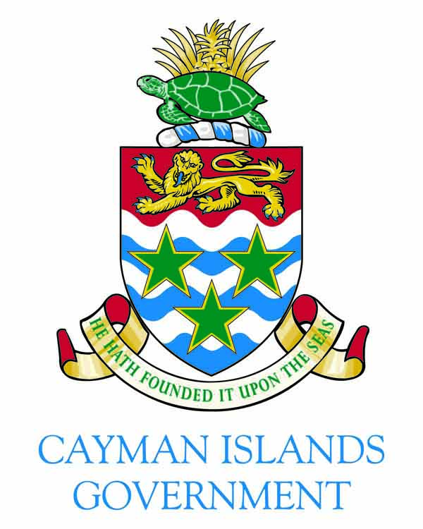
Her Excellency the Governor’s Acceptance Speech Legislative Assembly – 6 September 2013

CHECK AGAINST DELIVERY
Honourable Chief Justice
Honourable Speaker
Honourable Premier
Deputy Governor
Honourable Ministers and Members of Cabinet
Honourable Leader of the Opposition
Members of the Legislative Assembly
Commissioner of Police
Distinguished Ladies and Gentlemen

Thank you, Honourable Premier and Deputy Governor, for your kind words of welcome. It is with the utmost sense of honour and responsibility that I have today taken the oaths of allegiance to Her Majesty the Queen, and been sworn in as the twelfth Governor of the Cayman Islands.

I have committed to “well and truly serve the people of the Cayman Islands”.

My vision as Governor is one of partnership and cooperation, working with your elected representatives and public servants, with business, civil society and communities, to support the continued development of a safe, successful, and sustainable Cayman Islands.

I recognise that I have a great deal to learn. As a priority, I need to get to know the people of the Cayman Islands to find out what they aspire to and what causes them concern. I want to get around all of the districts, and the Sister Islands, as soon as possible. I aim to hear the views of as many people as I can, from those in the Brac and Little Cayman, to those between West Bay and East End.

Last year, the Prime Minister described the Overseas Territories in the UK Government’s White Paper as "an integral part of Britain's life and history". He went on to say that "we want to see our communities flourish in partnership, with strong and sustainable local economies". And he committed "to work with the territories to address the challenges we face together". The UK Government takes it responsibilities for the security and good governance of the Cayman Islands very seriously

Four years ago, my predecessor addressed this Assembly as the financial crisis and the global recession gripped the world. He highlighted then that this would present huge challenges, and there have certainly been difficult issues which introduced tensions into relationships. But despite this, the relationship between the Cayman Islands and the United Kingdom remains strong.

Like many, I welcomed the commitments made by the Cayman Islands at the recent G8 meeting in London to increase the transparency and co-operation of the financial services sector. These commitments helped to demonstrate that the Cayman Islands want to play a leading role in tackling the global problem of tax evasion.

But I noted in the run up to the G8, that many parts of the world found it difficult to understand the Cayman Islands properly. I look forward to helping to drive forward the global reputation of Cayman to one of a dynamic, well regulated, financial services centre.

And all this is in the wider context of the developing relationships between the UK and all of the Overseas Territories, through the annual Joint Ministerial Councils. I look forward to attending the next Council in late November, with the Premier.

Of course, a successful economy needs to have strong roots in good governance and the careful management of public finances. Some have already noted my background in this area, but I believe that effective stewardship of public money is a shared responsibility - from the members of this Assembly to those delivering front-line services for the residents of, and visitors to, the Cayman Islands and her beautiful shores.

Coupled with this, I fully support the steps that are being taken to improve the efficiency and effectiveness of the public administration, an issue covered by my predecessor in his farewell media interviews.

I welcome the measures that the Cabinet is taking to move forward with Standards in Public Life legislation. I believe that our values should ensure that we act with objectivity, honesty and integrity - collectively working to put the best interest of the Cayman Islands above any individual advantage.

But good governance does not mean interference, my ambition as Governor is to operate with a light touch, but being ready to change this approach if things go awry.

Where my involvement is certain to be greater will be in those areas where the constitution places particular responsibilities on the office of Governor: internal security, defence and preparedness for civil emergencies, and external relations. I recognise the public concern over recent robberies and burglaries. Working with the Royal Cayman Islands Police Service, I aim to maintain the focus on this critical area.

When I made my short visit here in July, I found the natural beauty of these islands truly captivating. The beauty of the islands was eclipsed only by the warmth of the welcome I received from those Caymanians and others I had the pleasure to meet. The Cayman Islands host an incredibly diverse range of wildlife, including 25 endemic species of plants and reptiles, and over 200 species of birds. Whilst the elected Government is responsible for the protection and conservation of the islands’ natural assets, I am committed to working with the Government and civil society to ensure that these assets are managed and protected in a manner that befits their incredible value.

Many commentators have noted I am the first female Governor of the Cayman Islands and I become the second woman to take up a governor position this year. This is something that I am particularly proud of. It is, perhaps natural therefore, that I hope to do what I can to champion the rights of women and tackle discrimination - in whatever form it takes. I look to support efforts to have the Convention to Eliminate All Forms of Discrimination against Women extended to the Cayman Islands. My vision is that all Caymanians and residents have the opportunity to take a leading role in shaping our future.

But for now, my first priority is to listen and learn; to get out into the community and to understand the issues that concern the people of the Cayman Islands. I look forward to getting around the Cayman Islands to do just that.

Lastly, but by no means least, may I offer my grateful thanks to Deputy Governor, Franz Manderson who has discharged his duties as Acting Governor in an exemplary manner.

I give you my commitment that, as your new Governor, I will work tirelessly to earn your trust.

May God bless the Cayman Islands!
(1046 words)

