Crime and Traffic Statistics Report 2017

With Explanatory Notes and Commentary

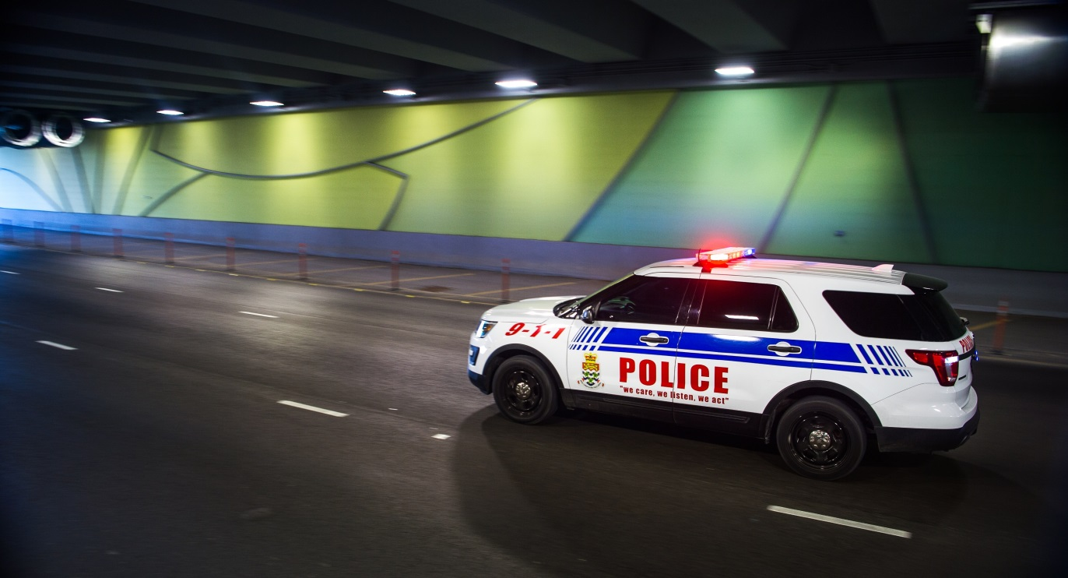

Figure 1: Cumulative Totals of Crimes, 2017 vs. 2016.

Crime Statistics for Cumulative Period January 01 - 31 December 2017 vs January 01 - 31 December 2016
CRIMES | 2017 Crimes | 2016 Crimes |  | Rate Of Change 16-17
Serious Crimes
Murder | 2 | 2 |  | 0
Attempted Murder | 5 | 8 |  | -3
Manslaughter | 0 | 0 |  | 0
Rape | 17 | 12 |  | 5
Attempted Rape | 1 | 2 |  | -1
Robbery | 31 | 34 |  | -3
Attempt Robbery | 6 | 6 |  | 0
Assault GBH | 26 | 28 |  | -2
Wounding | 18 | 17 |  | 1
Firearm | 25 | 36 |  | -11
Drugs | 168 | 189 |  | -21
Aggravated Burglary | 5 | 6 |  | -1
Burglary with intent to Rape | 2 | 0 |  | 2
Burglary | 515 | 439 |  | 76
Attempt Burglary | 81 | 62 |  | 19
Aggravated Criminal Trespass | 1 | 0 |  | 1
Criminal Trespass (Damage/Non Damage) | 153 | 90 |  | 63
Abduction/Kidnapping/Wrongful Confinement | 0 | 2 |  | -2
Human Smuggling | 1 | 0 |  | 1
Arson | 14 | 9 |  | 5
Defilement | 6 | 11 |  | -5
Other Assaults (Assault ABH/Assaulting Police) | 385 | 460 |  | -75
Indecent Assaults | 40 | 39 |  | 1
Other sexual Offences (Pornography/exposure/gross indecency/incest/Unnatural Offences/Pub. Doing Indecent Act) | 11 | 8 |  | 3
Child Cruelty & Neglect | 17 | 18 |  | -1
Threats to Kill/Intentional Harassment/Threat to Cause Serious Harm | 126 | 147 |  | -21
Fraud (Deception/Money Laundering/Forgery etc) | 62 | 75 |  | -13
Serious Crimes TOTAL | 1718 | 1700 |  | 18
Other Crimes
Common Assault | 186 | 185 |  | 1
Carrying restricted/Offensive Weapons | 12 | 26 |  | -14
Damage to Property | 432 | 450 |  | -18
Other Threatening Offences | 7 | 18 |  | -11
Use ICT to Harass, Annoy, Threaten or Defraud | 71 | 47 |  | 24
Motor Vehicle Theft | 53 | 28 |  | 25
Other Theft Offences | 717 | 753 |  | -36
Disorder Offences | 130 | 91 |  | 39
Public Order Offences | 405 | 377 |  | 28
Anti-Social Behavior | 32 | 137 |  | -105
Animal Offences | 66 | 41 |  | 25
Marine Offences | 6 | 13 |  | -7
Other Crimes TOTAL | 2117 | 2166 |  | -49
Other Offences (Type Not Recorded Above) | 35 | 35 |  | 0
OVERALL TOTAL | 3870 | 3901 |  | -31

Figure 1 summarizes crime totals for the years 2017 vs. 2016.

The overall cumulative incidence of crime across general categories has varied slightly year-on year, as such: Serious Crimes (less than 1%), Other Crimes (approximately 5%), Overall (less than 1%).

Figure 2: Burglaries by District

BURGLARY/ATT. BURGLARY - NATIONAL | 2017 Crimes | 2016 Crimes |  | Rate Of Change 16-17
Burglary/Att | RP | RP |  | +/-
National Total | 603 | 504 |  | 99
Residential | 424 | 376 |  | 48
Non-Residential | 179 | 128 |  | 51
Cayman Brac | 15 | 14 |  | 1
Bodden Town | 156 | 68 |  | 88
East End | 17 | 29 |  | -12
George Town | 290 | 276 |  | 14
Little Cayman | 2 | 0 |  | 2
Northside | 36 | 35 |  | 1
West Bay | 87 | 82 |  | 5

Figure 2 describes burglaries and burglary-related offences (burglary, attempted burglary, aggravated burglary and burglary with intent to rape) across all districts.

Typically, residential burglaries outnumber commercial burglaries; however, greater losses on average are reported in commercial burglaries. Both kinds of burglary increased overall in 2017.

Figure 3: Firearms Crimes

FIREARMS CRIMES | 2017 Crimes | 2016 Crimes |  | Difference 16 - 17
Firearms | RP | RP |  | +/-
FIREARMS CRIMES TOTAL | 25 | 36 |  | -11
Importation of an Unlicensed Firearm/Ammunition | 2 | 0 |  | 2
Possession of Unlicensed Firearm | 13 | 22 |  | -9
Possession of Unlicensed Firearm (Ammunition) | 2 | 3 |  | -1
Discharging Firearms | 3 | 8 |  | -5
Possession of a Bullet Proof Vest | 1 | 0 |  | 1
Possession of Imitation Firearm | 4 | 3 |  | 1

In Figure 3 Firearms Crimes are broken down into the six different categories.

In 2017, there were 25 confirmed firearm crimes, which was a decrease of 31% (11) compared to 2016. Firearm crimes in 2017 accounted for only 0.6% of all crimes recorded.

This decrease in firearm crimes occurred alongside a stark increase in the number of firearms recovered by police. In 2017 twenty-nine firearms were recovered, an increase of 61% over 2016, when 18 were recovered.

Figure 4: Drug Offences in 2017
DRUGS | 2017 Crimes | 2016 Crimes |  | Rate Of Change 16 - 17
Drugs | RP | RP |  | +/-
Importation of Ganja | 4 | 5 |  | -1
Importation of Cocaine | 1 | 1 |  | 0
Exportation of a Control Drug | 0 | 0 |  | 0
Smuggling (Drugs Other Contraband) | 4 | 1 |  | 3
Cultivation of Ganja | 2 | 1 |  | 1
Being Concerned in the Cultivation of Ganja | 1 | 0 |  | 1
Possession of Ganja | 80 | 82 |  | -2
Being Concerned in the Possession of Ganja | 3 | 12 |  | -9
Possession of Cocaine | 7 | 6 |  | 1
Possession of a control Drug (Not Cocaine or Ganja) | 0 | 3 |  | -3
Consumption of Ganja | 19 | 33 |  | -14
Consumption of Cocaine | 4 | 7 |  | -3
Consumption of a Controlled Drug (Not Cocaine or Ganja) | 0 | 5 |  | -5
Possession of Ganja with Intent to or Attempt to Supply | 25 | 14 |  | 11
Possession of Cocaine with intent to or Attempt to Supply | 7 | 4 |  | 3
Being Concerned in the Possession of Ganja with intent to Supply | 2 | 4 |  | -2
Being Concerned in the Possession of Cocaine with intent to Supply | 1 | 4 |  | -3
Dealing in Cocaine or Ganja | 1 | 0 |  | 1
Possession of Drug Paraphernalia | 6 | 7 |  | -1
Failing to Provide Specimen of Urine | 1 | 0 |  | 1
Control Drug Crimes Total | 168 | 189 |  | -21

Drug Offences are broken down into several categories, as shown in Figure 4. The largest drug seizures were of Cannabis (Ganja), followed by Cocaine (See Figure 5).

Overall, there was an 11% (21) decrease in drug crimes in comparison with 2016. However, possession of ganja with intent to supply increased by 79% (11). Drug offences account for 4% of all crimes recorded in the Cayman Islands in 2017.

Figure 5: RCIPS Drug Seizures in 2017

Discrete drug packages forensically processed during 2017: 562
Cannabis (Ganja) | Herbal Cannabis  Cannabis Resin | Total Weight Herb Seized = 742 kg/1635 lbs.  Total Weight Resin Seized = 7.7 grams
Cocaine | Cocaine | Total Weight Seized = 3.76 kg
 | Including:  Cocaine Hydrochloride  Cocaine Freebase  Cocaine Sulphate | Weight Seized = 3.66 kg  Weight Seized = 39.7 grams  Weight Seized = 34.6 grams
Ecstasy | MDMA | Total Weight Seized = 0.6 grams
Amphetamine | Amphetamine | Total Weight Seized = 10.7 grams

Figure 5 is compiled based upon requests for forensic examinations of recovered drugs. In 2017, 562 requests were made for such forensic examinations. The drugs that were processed are broken down into the different categories shown, showing the total weight in each category.

Figure 6: Cyber Crime by Type, 2010-2017
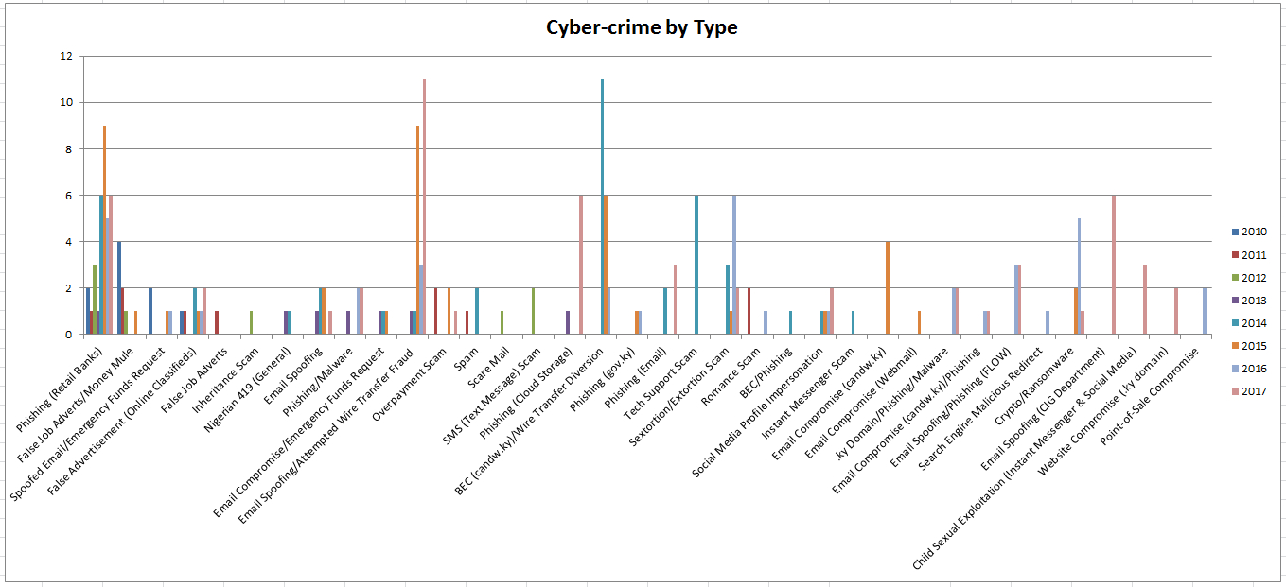

Cyber crime incidents are not included in the overall crime figures due to their variance and complexity. However, Figures 6 & 7 are being included in this document in order to begin to illustrate this area of criminal activity for the benefit of public awareness. In 2010, cyber-crime incidents were extremely rare to non-existent. Cyber crime reports started to spike in 2014, and have continued to rise since that time.

Figure 7: Annual Cyber Crime Incidents, 2010-2017

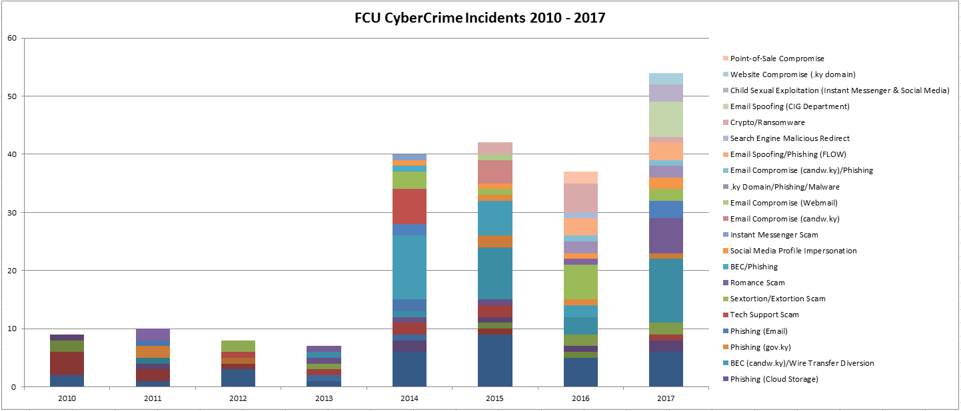

TRAFFIC - NATIONAL | 2017 |  |  |  |  | 2016 |  |  |  |  | Year-on-Year Comparison
 |  |  |  |  |  |  |  |  |  |  | 2017 YTD | 2016 YTD | Rate Of Change 16-17
 | Q1 | Q2 | Q3 | Q4 |  | Q1 | Q2 | Q3 | Q4
Traffic Accidents and Enforcement
Fatal | 0 | 1 | 1 | 1 |  | 3 | 1 | 1 | 2 |  | 3 | 7 | -4
Serious Injuries | 10 | 4 | 7 | 9 |  | 4 | 6 | 3 | 3 |  | 30 | 16 | 14
Slight/Possible Injuries | 81 | 75 | 61 | 48 |  | 130 | 55 | 52 | 127 |  | 265 | 364 | -99
Damage Only | 592 | 579 | 599 | 657 |  | 177 | 254 | 245 | 232 |  | 2427 | 908 | 1519
Traffic Collision TOTAL | 683 | 659 | 668 | 715 |  | 314 | 316 | 301 | 364 |  | 2725 | 1295 | 1430
Traffic Enforcement
Driving Under the Influence | 48 | 49 | 63 | 78 |  | 53 | 52 | 48 | 51 |  | 238 | 204 | 34
Using Mobile Phone Whilst Driving | 159 | 79 | 187 | 168 |  | 163 | 173 | 174 | 245 |  | 593 | 755 | -162
Speeding | 197 | 113 | 145 | 192 |  | 402 | 362 | 551 | 387 |  | 647 | 1702 | -1055
Driving Without Been Licensed | 33 | 23 | 24 | 23 |  | 36 | 27 | 29 | 27 |  | 103 | 119 | -16
Driving Without Insurance | 51 | 47 | 58 | 29 |  | 52 | 35 | 35 | 44 |  | 185 | 166 | 19
Failing to Wear Seat Belt | 35 | 46 | 95 | 56 |  | 126 | 83 | 196 | 281 |  | 232 | 686 | -454
Careless Driving | 62 | 56 | 37 | 12 |  | 41 | 56 | 41 | 51 |  | 167 | 189 | -22
Dangerous Driving | 6 | 6 | 3 | 0 |  | 1 | 4 | 2 | 7 |  | 15 | 14 | 1
Causing Death by Dangerous Driving | 0 | 0 | 1 | 0 |  | 1 | 0 | 0 | 0 |  | 1 | 1 | 0
All Other Traffic Offences | 766 | 388 | 756 | 732 |  | 789 | 548 | 785 | 826 |  | 2642 | 2948 | -306
Traffic Offences Total | 1357 | 807 | 1369 | 1290 |  | 1664 | 1340 | 1861 | 1919 |  | 4823 | 6784 | -1961
Figure 8: Traffic Collisions and Road Enforcement, 2017 vs. 2016

The number of fatal accidents on the islands fell for the second straight year, with only three (3) fatal accidents occurring in 2017, causing six (6) road deaths in total. In 2016 seven (7) fatal accidents caused seven (7) road deaths. At the same time, accidents causing serious injury have nearly doubled. The total number of traffic collisions throughout the islands registered a large increase, from 1295 to 2725. Eighty-nine percent of these were categorized as “damage only” road collisions.

