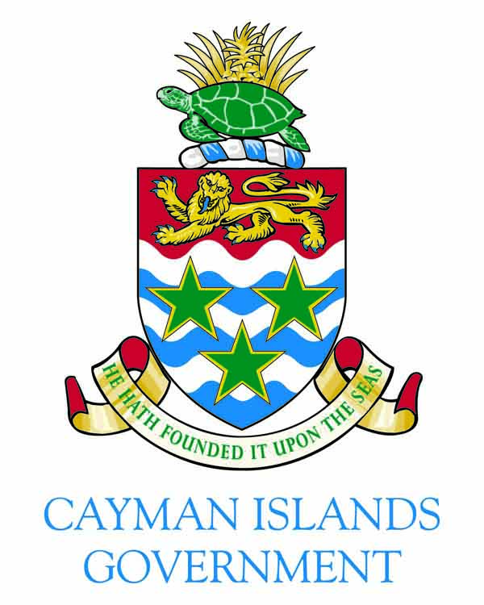
His Excellency the Governor’s Acceptance Speech Legislative Assembly – 26 March 2018

Honourable Chief Justice
Honourable Speaker
Honourable Premier
Honourable Deputy Governor
Honourable Ministers and Members of Cabinet
Honourable Leader of the Opposition
Members of the Legislative Assembly
Commissioner of Police
Distinguished Ladies and Gentlemen

Thank you, Honourable Premier and Deputy Governor, for your kind words of welcome. I feel deeply humbled and honoured today to accept the responsibility of my appointment as the Governor of the Cayman Islands.

This is my first experience of working in an Overseas Territory and I know that I will have much to learn in the months and years ahead. I hope that my long experience in the Civil Service, the private sector and the military has equipped me well to serve the people of the Cayman Islands effectively. I can assure you all that I intend to uphold and defend our constitution, laws and the prosperity of our islands to the best of my ability.

I am looking forward to working with the Premier and the members of this Legislative Assembly as we tackle the difficult and challenging issues that we will encounter in the years ahead. I know that the Cayman Islands have a strong and independent civil service ably led by the Deputy Governor, and a police force which is the envy of the other Overseas Territories. I will also defend your integrity and strive for continual progress, innovation and improvement.

I hope that my first days in Cayman will be spent getting to know these beautiful islands and meeting as many Caymanians and residents as possible. I hope to visit the people of Cayman Brac and Little Cayman on Wednesday. I am here to serve you and I want to hear your views and your ideas. I am energised by people’s hopes and dreams, nothing gives me more pleasure than to serve. You will find my door open to you and I will defend your rights and prosperity with everything I have at my disposal.

Initially I intend to focus my efforts and those of my office on four areas that I see as particularly important.

I see security as my first duty. We are fortunate to have an experienced and dedicated Commissioner of Police and I know his team is committed to our safety and security. The staff in the Governor’s Office and I will not compromise in this area. It is our responsibility to keep these islands safe so we can enjoy our quality of life and not lose it to crime. We see examples from around this region where a breakdown in law and order has led to serious consequences for the social and economic stability of other states. We must not let this happen here. Security needs professional staff and adequate resourcing and we need to work together with the UK and partners in the region to ensure that we are keeping pace with the criminal and external threats that seek to undermine our way of life. I know that there is already much work being undertaken in this area and I will continue to support and enhance this.

I welcome the recent statement made to this Assembly by the Honourable Premier setting out some of the important initiatives we are engaged on to create a new Border Protection Service and Coastguard. I fully agree that we need to work closely together through the National Security Council as we take strategic security decisions whilst at the same time ensuring that operational decisions are left to professional law enforcement agencies. I hope we can hold my first NSC meeting as soon as possible.

Secondly I will work to protect the interests of Cayman business and in particular our financial services industry.
This territory is well served by one of the world’s biggest and most professional financial centres. This underpins the economy and sustains the way of life of Caymanians and I look forward to working with the industry, where I started my career, and with regulators in Cayman and colleagues in the UK and the EU to ensure a prosperous and stable future.

Our economy and the fabric of Cayman society is underpinned by a world renowned judiciary. Our judges, lawyers and court staff are vital to the financial success and security of the islands. It is no surprise that businesses from around the world choose to do business here when the rule of law is protected in this way.
Both the UK and the Cayman Islands are tolerant and welcoming societies and Human rights will also be a priority area for me. I have spent much of my career trying to up-hold peoples’ rights and striving for equality and tolerance. All Caymanians and residents of these islands have their rights protected by the constitution and by the international obligations to which we have subscribed. I know that some aspects are sensitive in Cayman but my compass on rights issues will always be the law and I will defend the rights of all groups of people here regardless of their race, colour, religion, gender, disability or sexual orientation. I look forward to working closely with the Human Rights Commission on these issues.

My final priority will be to develop closer people to people links between the UK and the Cayman Islands. We have strong family, historical and constitutional bonds. I would like to see these strengthen further with more business, educational and cultural links being established and embedded. In the UK we are talking about a new era of “Global Britain” and the Overseas Territories are part of Global Britain. I arrive in Cayman at the start of a period of change and I know that there are many challenging issues that we have to address. But as the UK leaves the European Union, risks and opportunities will be created for the Overseas Territories. I am optimistic about this and also see it is a chance for the UK and the Cayman Islands to forge closer links than ever before. I want to make sure that you really feel that your voices are heard in London and that we work together on the world stage. The visit that the Honourable Premier and Ministers made to Hong Kong last week to take part in the Great Festival of Innovation is a good example of where we can work together to promote trade opportunities. I see the facilitation of these new opportunities as a key role for me and my team.

The Cayman Islands are blessed with amazing biodiversity and tourists flock here to enjoy your pristine environment and fantastic wildlife. Although the elected Government is directly responsible for the protection of the environment, including the use of renewable energy for which I have a real passion, I hope to work closely with you to keep the Cayman Islands as a place of beauty and a home to the diverse marine life and endemic species that are found here.
I would like to pay tribute to Governor Kilpatrick for her dedicated service to these islands. As Cayman’s first female Governor I know she has left a positive legacy for me follow. As has been reported in some sections of the media, I am Cayman’s first Muslim Governor. But I do not see it that way. I am first and foremost Her Majesty’s Governor and your Governor. I am honoured to have been appointed and to have the chance to serve you.

I arrived this morning with my wife, Momina and three children, Amani, Ambreene and baby Emilia. They too are excited about coming to such a wonderful place and are looking forward to starting their new lives here. My son Umar who works in the financial industry in London may join me later. We all have a lot to learn and I am keen to get started straightaway.

Finally I would like to thank Deputy Governor Franz Manderson for the exemplary manner in which he has covered as Acting Governor over the last 3 weeks. Also my thanks to the staff of the Governor’s Office and other government departments for making my arrival as smooth as possible.

I look forward to meeting and working with you all.

May God Bless the Cayman Islands.

